My 5 Point Scale by _______________
 | My body looks and feels like this | These words or pictures show how I feel | I can do this to help
5 |  | 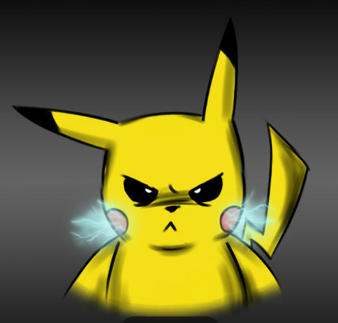
4 |  | 
3 |  | 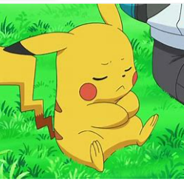
2 |  | 
1 |  | 

Date completed:

