5 | Out of Control  The Thing  I feel like I am about to explode! I feel completely overwhelmed and may become unsafe. | 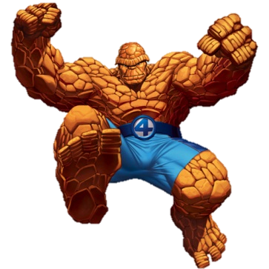
4 | Starting to Lose It  The Hulk  I’m getting very angry and I may start to say things I don’t mean. | 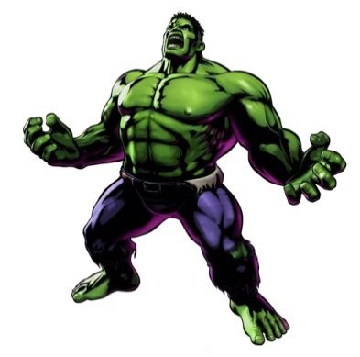
3 | Anxious/Worried/Excited  The Flash  I feel like I need to run away as fast as I possibly can. | 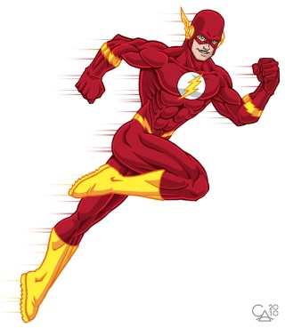
2 | I Think I Can Handle It  Spiderman  I am going to push myself to try my very best even if it is hard. I will feel proud when I get through it. | 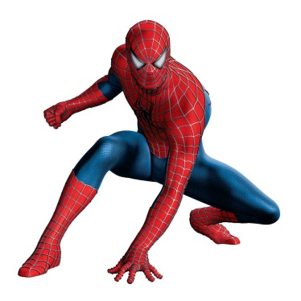
1 | Just Right  Superman  Nothing can bring me down! I am a man of steel and feel on top of the world! | 

