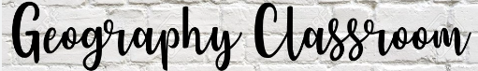


Key Stage 1 geography: children develop knowledge about the world, the United Kingdom and their locality; understand basic vocabulary relating to human and physical geography and begin to use geographical skills.
Year 3 & 4 Cycle A
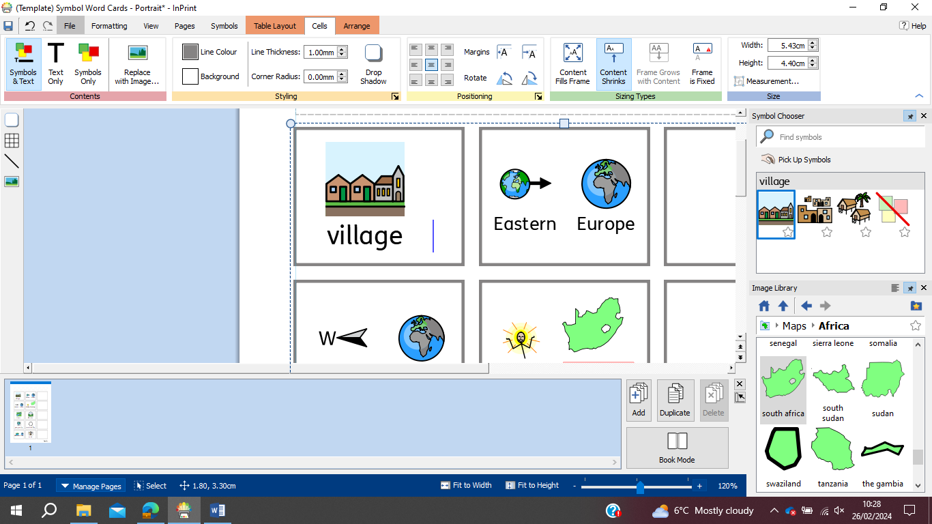
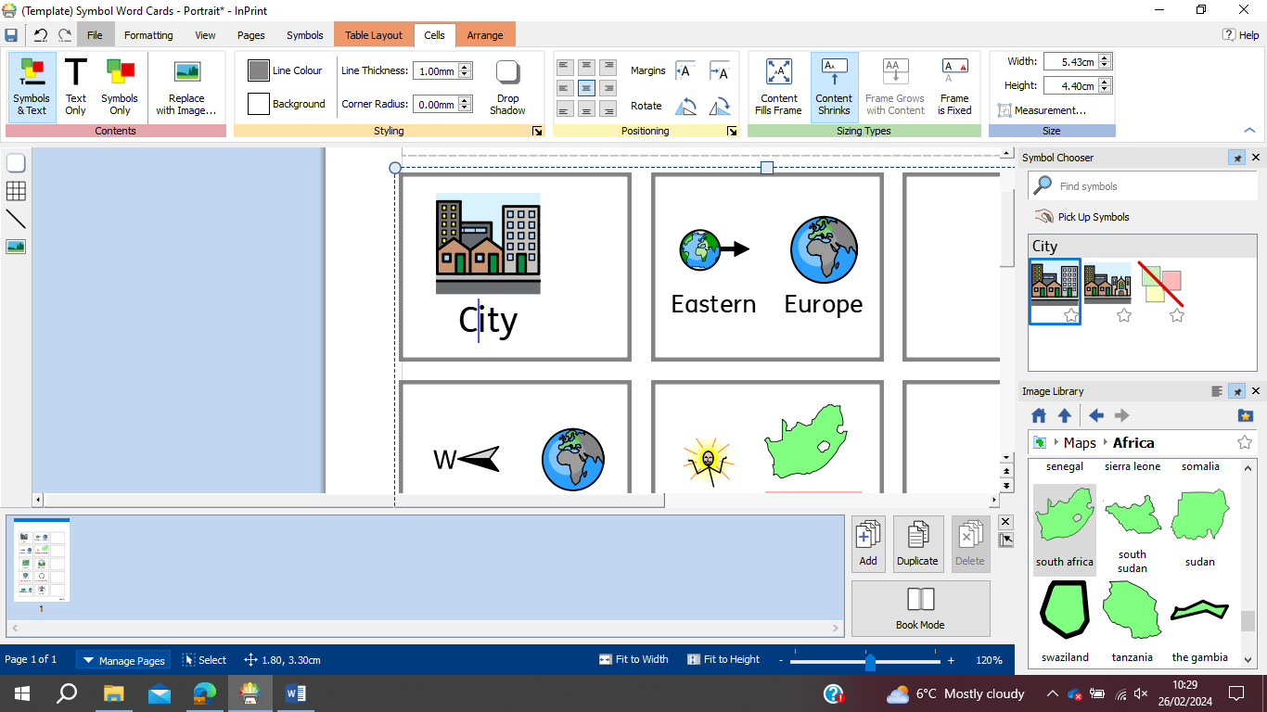
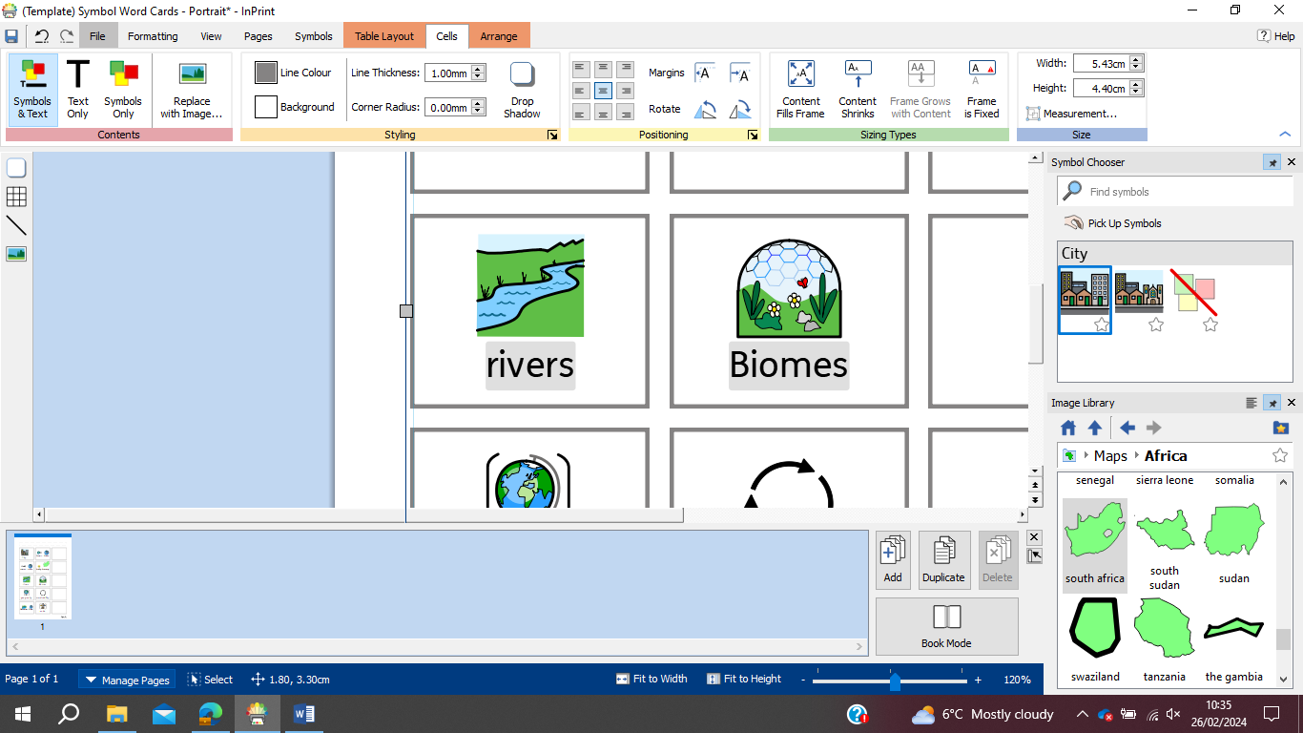
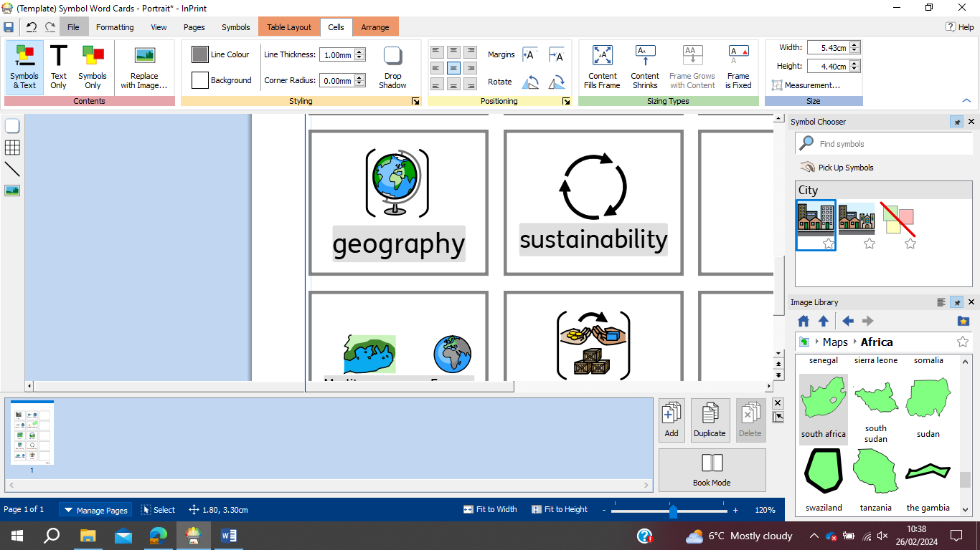

Rivers
Settlements
Geography Skills
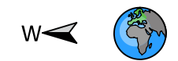
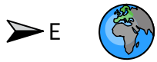

Eastern Europe
Geography Skills
Western Europe
Year 3 & 4 Cycle B

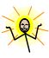
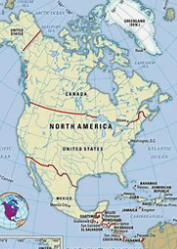
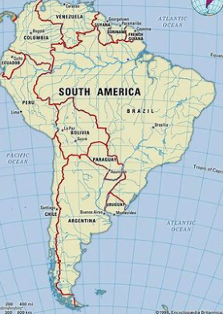

North America
South America
Geography Skills
Year 5:

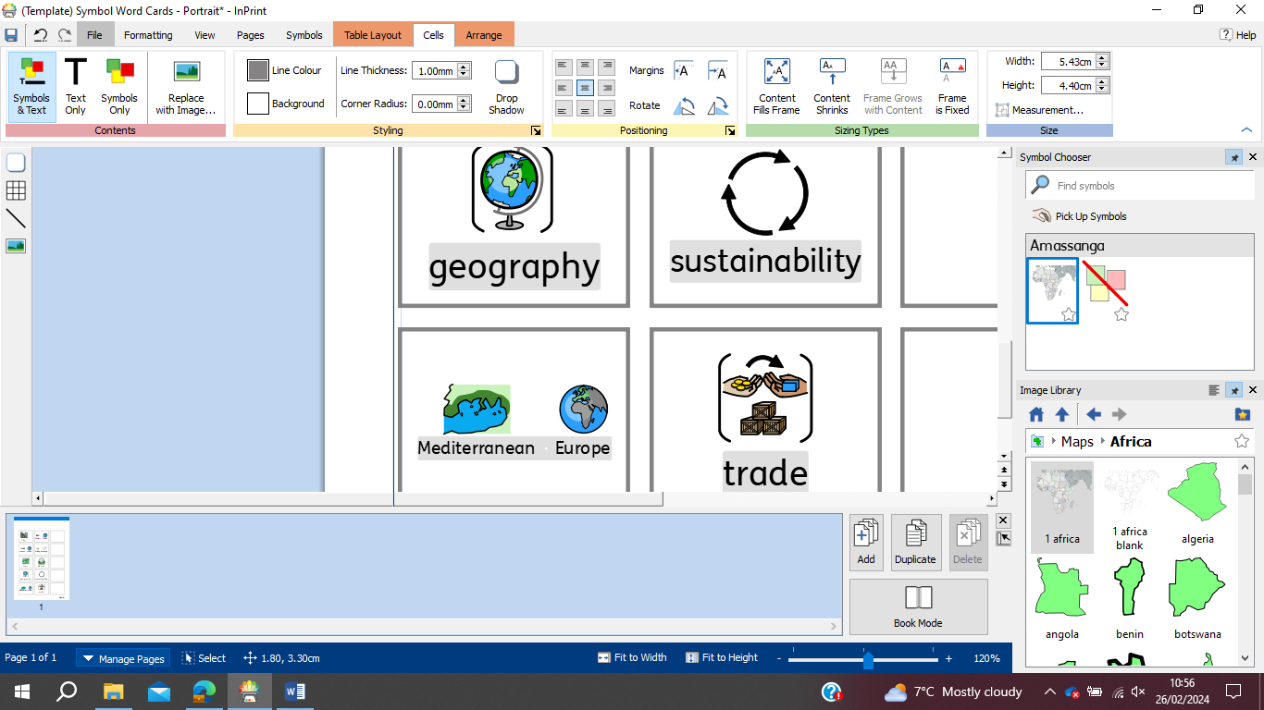
Year 6:
British Issues
Globalisation
Geography Skills

