


How will my child’s special education needs be supported at Studley?
All children will have access to the following forms of support

Nurture – space available as a drop in at lunchtime and breaktimes with an adult available to provide support and discussion.
PSHE – every child has a PSHE lesson once a week through our ‘Jigsaw’ programme.
Calm corners – calm spaces within academy for children to use if they feel angry, upset, anxious, sad or stressed to regulate, refocus and return to learning. Spaces are in every classroom and other key areas across the academy. All children are taught a range of calming strategies that they can use.
Good to Talk – post boxes in every classroom and other key areas across the academy where children can write a worry or concern. Staff check these boxes daily and speaks to the child about their worry.
Mental Health in Schools Team – we work closely with this NHS team who regularly offer whole class sessions. Recent sessions have included relaxation and emotional awareness.
Support for families – All families can access support from CWRISE For Parents and Carers | CAMHS (cwrise.com), ‘Parenting your child with additional needs on line course (Warwickshire), Family Information Service (Warwickshire)
Skilled staff – our staff have had training in attachment and supporting children’s social and emotional needs. We support children to manage their social and emotional concerns as they arise during the academy day through discussion, reflection, modelling and direct teaching. Class teachers and other staff are available to talk through concerns.
Little Wandle – A streamed phonics teaching method that is used in Year 3 to support children who have not passed the phonics screening check
Reading fluency– A regular reading fluency programme to support children who are not yet reading fluently to ensure rapid catch up
Visual Timetables – timetable to show visually what is coming up during the day
Widgit symbols – Visual representations on displays to support children’s learning and understanding of key vocabulary.
Some children will have a slightly greater need and may be offered the following forms of support (as appropriate)

All about me plans – for children who are not working on specific targets but need low level adaptations to their learning and environment to meet their needs
Individual Education plans – a personalised plan stating what support is in place to meet specific small steps of progress
Adaptive sensory aids – a range of physical aids to support sensory regulation are available for children in the classroom.
Adaptive teaching aids – a range of scaffolds to support children to access the curriculum including Now/Next boards, widget symbols, sentence strips, etc
Further support for phonics – Little Wandle catch up and SEND programme, Rainbow phonics and Toe by Toe to offer further support for children who are not making progress through the phonics scheme
Fine motor skills – Intervention to support fine motor skills for pencil grip and handwriting
Adaptive physical aids – Writing slopes, pencil grips, and footrests are available
Mental Health referrals – referral for additional support from the Mental Health in Schools Service
Signposting – Families signposted to local and national support groups
Therapy Dog – greet in the mornings or 1:1 sessions with children with identified targets
Highly qualified staff team – All staff are trained by the Autism Education Team, across the staff team there are experts in PDA, SALT, Dyslexia, literacy and maths calculations, sensory support. The SEND assistant and SENDCo are available for appointments to discuss concerns and advise teachers. The Headteacher is a qualified SENDCo.
Nessy – an online dyslexia intervention

A few children will have high levels of special educational needs and require highly personalised levels of support

Education Health Care Plan – applications for an EHCP can be sent to Warwickshire by the academy of parents for extra support and funding for a child
Education Health Care Plan in school – once an educational and health care plan has been written by the local authority, the school will put into place the physical and human resources that are needed. Support will be requested for training if needed.
Sensory Circuits – for children with externally identified sensory and/or gross motor needs
Yoga – to support sensory and gross motor needs
Bespoke maths and literacy programs -tailored to meet individual EHCP targeted needs
Adapted foundation subject curriculum - tailored to meet individual EHCP targeted needs
Please speak to ANY member of staff if you are concerned about your child’s special education needs. We are here to help
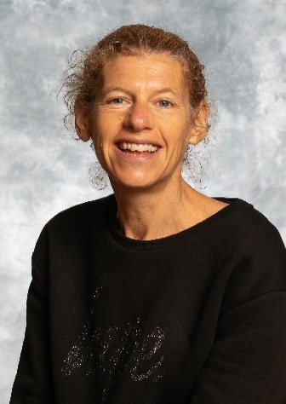
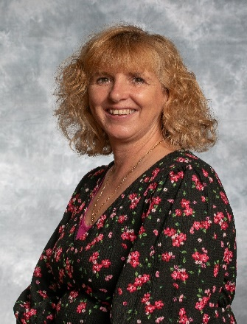
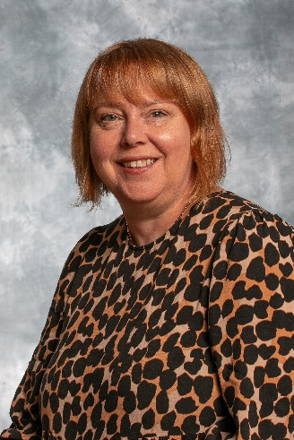
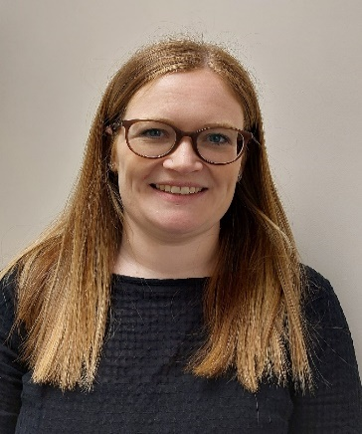
Ms Steven – Therapy Dog lead
Mrs Bailey – Base Lead
Mrs Kirkland – SEND Assistant
Mrs Dargie - SENDCo

